Churches Together in Otley


The people of God working
and praying as one

For details of each church look at the other leaflet or on the internet

Churches Together in Otley represents:

All Saints Parish Church(C of E)

Quakers (The Religious Society of Friends)

Our Lady and All Saints Catholic Church

Salvation Army

New Life Christian Centre

Methodist Church

The Bridge Church
– The United Reformed Church

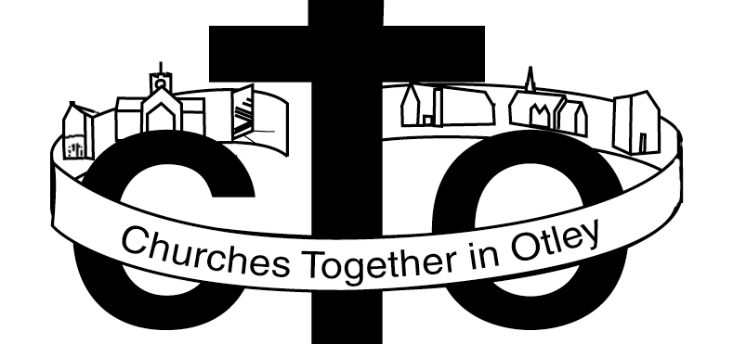Website www.otley.co.uk/churches/

“What it does” 2010

Study
- Ecumenical Study Groups
- Friday Lunchtime
- Lent Meetings
- Marriage Enrichment Course

Prayer
- Ecumenical Prayer Groups
- Prayer Breakfasts - Monthly

Holy Week events

Services
- Remembrance Sunday

Week of Prayer for Christian Unity Service

Easter Sunday - Joint Service 7.00am

Easter Sunday on the Chevin

Pentecost

Action
- Large Cross on Chevin
- Small Cross in Market Place
- Christian Aid Week - May -House Collection throughout the town
- Bible Society Women’s Rally

Community Work

Weston Estate Venture
- Activities for young people
- French Connexion 2006
- Investigation into the possibility of Credit Union
- Exploring the need for counseling in the Town
- Faith in Schools
- Otley in Bloom
- Support for Mayor – donate a bible at the Civic Service
- Working with young people

In the past

Buttercross sale for Bible Soc.
One World Week / Exhibition
Week of Prayer for World Peace
Carol Service - Christmas Tree lights
Carols in the Hospital
Victorian Fayre Dec
Other Christmas Events
Lent House Study Groups

Easter Street Drama
Hot Cross Buns at Easter in the Market
Easter Activities
Pentecost - Procession – joint Service
Joint Schools Concert- Christian Aid
Sponsored Walk for Christian Aid
Otley Carnival - Float & Stalls
Saturday Evening Shared Worship
People next door - - Good neighbours scheme

Party in the Park
Initial research into needs of Elderly in preparation for Otley Action for Older People
Special Services – For Farmers during the Foot and Mouth troubles

Together, the churches work and pray and
individually each church works and prays

Website www.otley.co.uk/churches/

